# Višeslojna klasifikacija u Pythonu

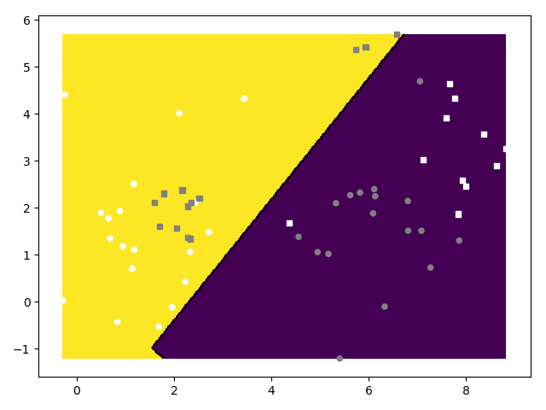

# Linearna regresija u Tensorflowu

Message: [[-12.3334 0][-8]...][[-123334 0][-80000]...][-12.3334][-8]

[[mean_grad_a, a][mean_grad_b, b]…][[grad_a, a][grad_b, b]…][dl_da][dl_db]

0 16.3334 1.23334 0.8

I avg(loss) a_val, b_val

# Logistička regresija u Tensorflowu

Bez regularizacije:

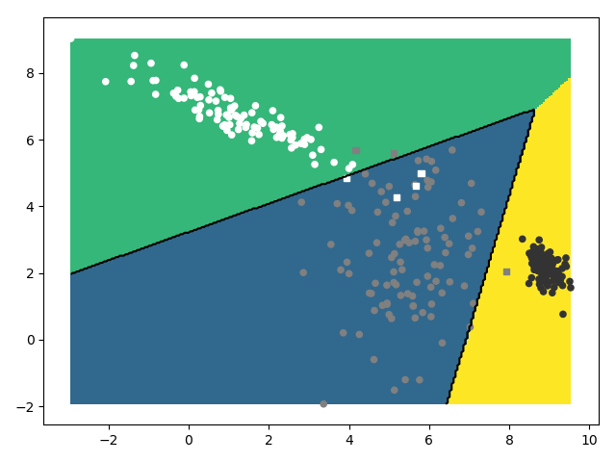

999 26.307955

acc 0.9766666666666667

recall [(0.97, 0.9603960396039604), (0.96, 0.9795918367346939), (1.0, 0.9900990099009901)]

precision [[ 97 2 1]

[ 4 96 0]

[ 0 0 100]]

Identični rezultati kao i u 0. vježbi.

S L2 regularizacijom:

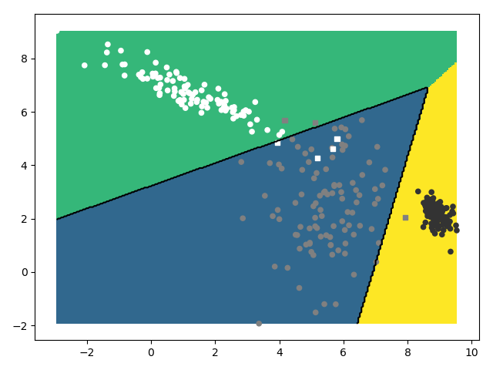

999 26.374212

acc 0.9766666666666667

recall [(0.97, 0.9603960396039604), (0.96, 0.9795918367346939), (1.0, 0.9900990099009901)]

precision [[ 97 2 1]

[ 4 96 0]

[ 0 0 100]]

Nema značajnih doprinosa

Greška:

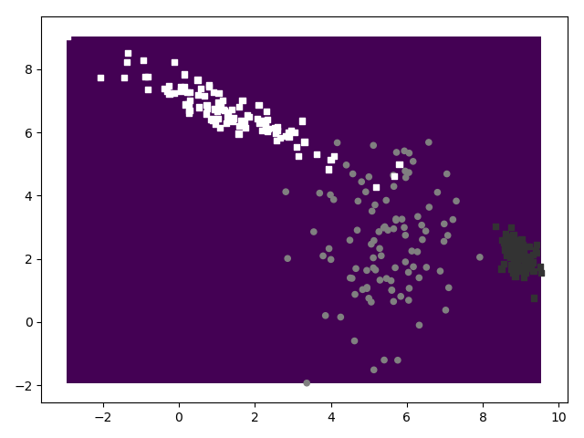

Param_delta = 5

999 nan

acc 0.3333333333333333

recall [(1.0, 0.3333333333333333), (0.0, nan), (0.0, nan)]

precision [[100 0 0]

[100 0 0]

C:\Users\pavao\Documents\faks\du\labs\lab1\data.py:137: RuntimeWarning: invalid value encountered in longlong_scalars

[100 0 0]]

Stopa učenja je prevelika pa postupak divergira.

# Konfigurabilni modeli u Tensorflowu

[2,3]



999 26.374212

acc 0.9766666666666667

(precision, recall)

[(0.97, 0.9603960396039604), (0.96, 0.9795918367346939), (1.0, 0.9900990099009901)]

M

[[ 97 2 1]

[ 4 96 0]

[ 0 0 100]]

Rezultati su isti

b)

[<tf.Variable 'W0:0' shape=(2, 3) dtype=float32_ref>, <tf.Variable 'b0:0' shape=(3,) dtype=float32_ref>] 9

C)

tanh

data.sample_gmm_2d(4, 2, 40)

[2,2]

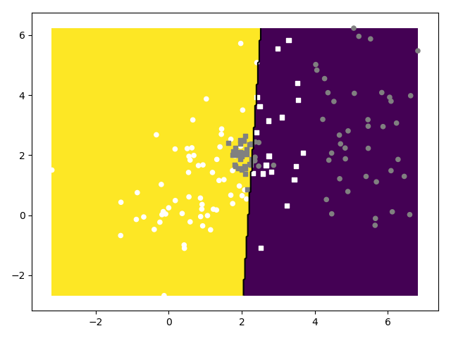

acc 0.675

(precision, recall) [(0.5875, 0.7121212121212122), (0.7625, 0.648936170212766)]

M

[[47 33]

[19 61]]

[2,10,2]

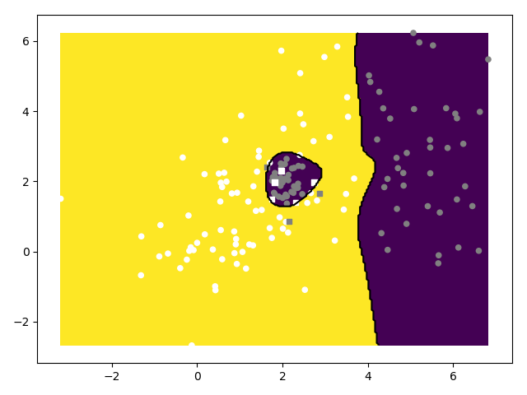

acc 0.95

(precision, recall)

[(0.9625, 0.9390243902439024), (0.9375, 0.9615384615384616)]

M

[[77 3]

[ 5 75]]

[2,10,10,2]

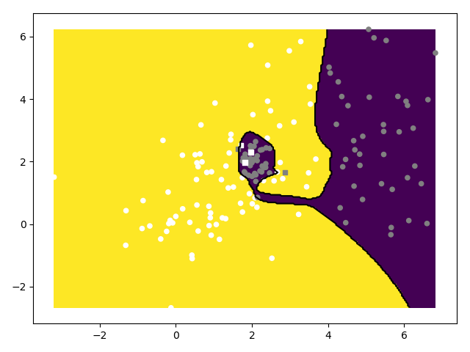

acc 0.96875

(precision, recall)

[(0.975, 0.9629629629629629), (0.9625, 0.9746835443037974)]

M

[[78 2]

[ 3 77]]

 data.sample_gmm_2d(6, 2, 10)

[2,2]

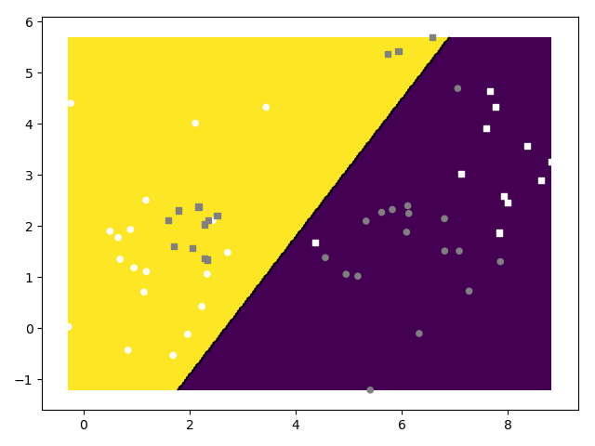

acc 0.6

(precision, recall)

[(0.5666666666666667, 0.6071428571428571), (0.6333333333333333, 0.59375)]

M

[[17 13]

[11 19]]

[2,10,2]

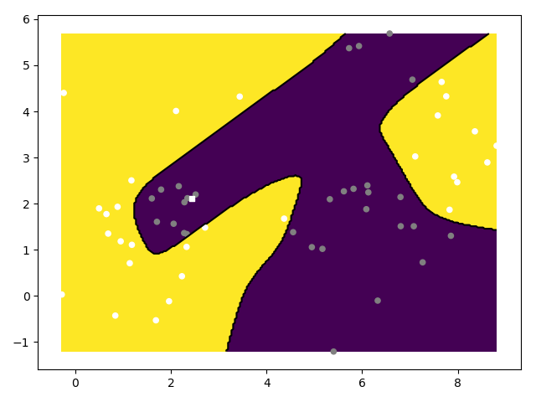

acc 0.9833333333333333

(precision, recall)

[(1.0, 0.967741935483871), (0.9666666666666667, 1.0)]

M

[[30 0]

[ 1 29]]

[2,10,10,2]

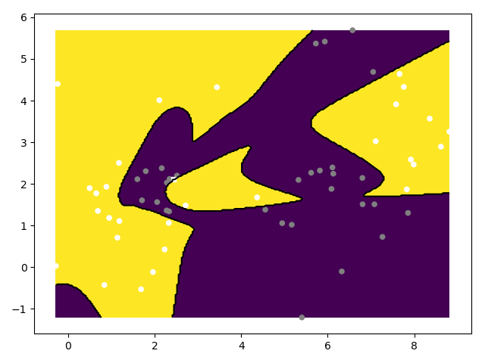

acc 0.9833333333333333

(precision, recall)

[(1.0, 0.967741935483871), (0.9666666666666667, 1.0)]

M  
[[30 0]

[ 1 29]]

D)

Sigmoid

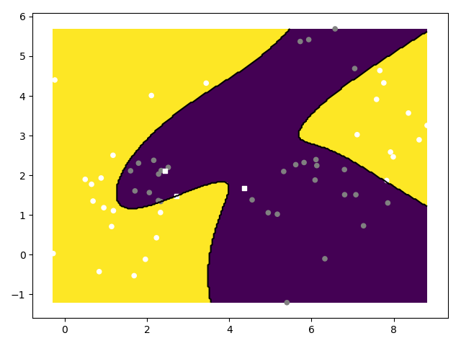

acc 0.95

recall [(1.0, 0.9090909090909091), (0.9, 1.0)]

precision [[30 0]

[ 3 27]]

# Usporedba s jezgrenim SVM-om

B)

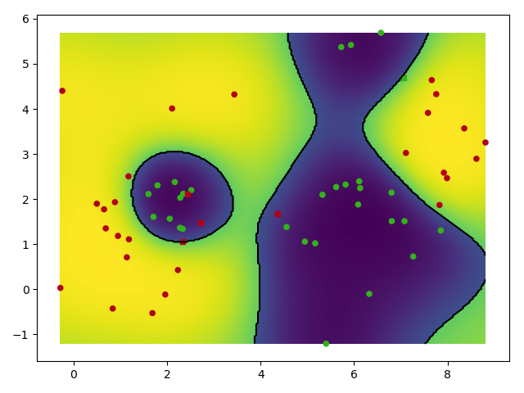

acc 0.9166666666666666

recall [(0.9666666666666667, 0.8787878787878788), (0.8666666666666667, 0.9629629629629629)]

precision [[29 1]

[ 4 26]]

d)

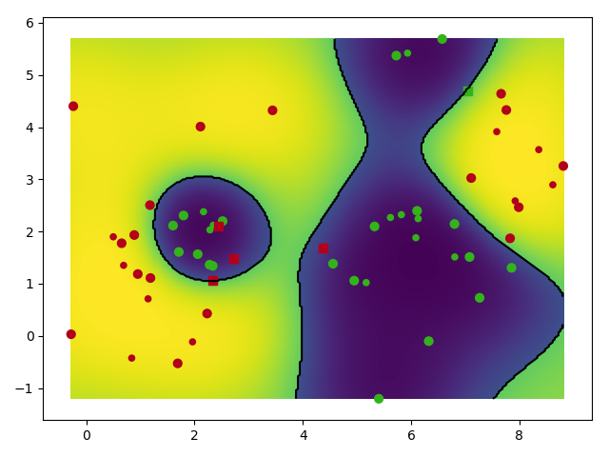

# Studija slučaja: MNIST

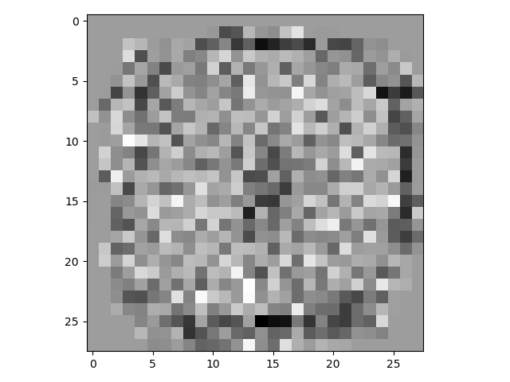

Težine za prvi neuron

[784, 10]

0.909

(0.907965464397653, [0.9247104247104247, 0.9650655021834061, 0.916923076923077, 0.8659112370160529, 0.9285714285714286, 0.8777393310265282, 0.9335410176531672, 0.90625, 0.8598326359832636, 0.9011099899091827])

(0.9076986249886196, [0.9775510204081632, 0.973568281938326, 0.8662790697674418, 0.907920792079208, 0.90020366598778, 0.8531390134529148, 0.9384133611691023, 0.9309338521400778, 0.8439425051334702, 0.8850346878097126])

[[ 958 0 12 3 1 14 14 2 18 14]

[ 0 1105 12 0 1 4 3 6 8 6]

[ 2 7 894 17 10 3 11 21 10 0]

[ 4 3 28 917 2 44 2 9 37 13]

[ 1 0 5 1 884 10 7 3 9 32]

[ 8 1 7 30 1 761 16 2 32 9]

[ 5 4 12 2 14 13 899 0 13 1]

[ 2 2 19 14 9 5 3 957 12 33]

[ 0 13 40 21 13 34 3 2 822 8]

[ 0 0 3 5 47 4 0 26 13 893]]

[784, 100, 10]

0.9589

(0.9588755745725628, [0.9745417515274949, 0.9841549295774648, 0.9588235294117647, 0.9342995169082126, 0.9558232931726908, 0.9739336492890995, 0.9578189300411523, 0.9521072796934866, 0.9420289855072463, 0.9552238805970149])

(0.9582098566840612, [0.976530612244898, 0.9850220264317181, 0.9476744186046512, 0.9574257425742574, 0.9694501018329938, 0.92152466367713, 0.9718162839248434, 0.9669260700389105, 0.9342915811088296, 0.9514370664023786])

[[ 957 0 3 1 1 5 4 0 6 5]

[ 0 1118 2 1 1 1 3 3 5 2]

[ 3 3 978 6 5 3 3 12 7 0]

[ 1 2 11 967 1 29 2 1 12 9]

[ 1 0 8 1 952 4 6 8 3 13]

[ 5 1 0 7 0 822 2 0 5 2]

[ 6 4 5 1 6 12 931 0 7 0]

[ 3 1 9 9 4 3 1 994 6 14]

[ 1 6 13 14 1 7 6 4 910 4]

[ 3 0 3 3 11 6 0 6 13 960]]

[784, 100, 100, 10]

0.951

(0.9507142926072494, [0.9656912209889001, 0.983274647887324, 0.9367209971236817, 0.9379310344827586, 0.9515151515151515, 0.9466515323496028, 0.9713983050847458, 0.9531405782652044, 0.921, 0.9398194583751254])

(0.9505586676448493, [0.976530612244898, 0.9841409691629956, 0.9467054263565892, 0.9425742574257425, 0.9592668024439919, 0.9349775784753364, 0.9572025052192067, 0.9299610894941635, 0.9455852156057495, 0.9286422200198216])

[[ 957 0 6 1 1 5 11 1 4 5]

[ 0 1117 3 0 4 0 3 4 0 5]

[ 5 5 977 13 6 3 9 19 5 1]

[ 4 2 12 952 0 15 1 8 8 13]

[ 1 0 5 0 942 3 4 7 5 23]

[ 3 0 1 19 0 834 7 2 12 3]

[ 6 3 3 1 3 8 917 0 2 1]

[ 0 1 10 8 4 3 0 956 9 12]

[ 4 7 14 9 5 16 6 9 921 9]

[ 0 0 1 7 17 5 0 22 8 937]]

[784, 100, 100, 100, 10]

0.9514

(0.951168322800029, [0.970498474059003, 0.9806338028169014, 0.9501466275659824, 0.9325513196480938, 0.9324055666003976, 0.953970080552359, 0.9678756476683937, 0.9551219512195122, 0.9168336673346693, 0.9516460905349794])

(0.9509404531979445, [0.9734693877551021, 0.9814977973568282, 0.9418604651162791, 0.9445544554455445, 0.955193482688391, 0.929372197309417, 0.9749478079331941, 0.9523346303501945, 0.9394250513347022, 0.9167492566897919])

[[ 954 0 7 1 0 4 6 1 4 6]

[ 0 1114 1 0 0 0 2 8 5 6]

[ 8 6 972 9 6 3 1 14 1 3]

[ 1 2 9 954 1 26 2 6 12 10]

[ 2 0 5 3 938 5 6 6 7 34]

[ 3 2 2 13 3 829 2 2 9 4]

[ 7 2 2 0 5 7 934 0 7 1]

[ 3 3 10 6 5 2 0 979 7 10]

[ 1 6 24 19 5 12 5 1 915 10]

[ 1 0 0 5 19 4 0 11 7 925]]

SVM

ovr

0.9439

0.9434119095693914 [0.9602780536246276, 0.9671848013816926, 0.9375, 0.9259259259259259, 0.9268051434223541, 0.9298850574712644, 0.9458077709611452, 0.9578736208625878, 0.941921858500528, 0.9409368635437881]

0.9431582105251788 [0.986734693877551, 0.986784140969163, 0.9302325581395349, 0.9405940594059405, 0.9541751527494908, 0.9069506726457399, 0.965553235908142, 0.9289883268482491, 0.9158110882956879, 0.9157581764122894]

[[ 967 0 8 0 1 7 9 2 4 9]

[ 0 1120 1 1 1 5 3 13 7 7]

[ 1 2 960 16 7 5 4 22 7 0]

[ 0 3 9 950 0 32 1 5 14 12]

[ 0 0 11 1 937 7 6 8 8 33]

[ 5 1 1 17 0 809 9 0 23 5]

[ 5 3 14 1 8 11 925 0 10 1]

[ 1 1 8 9 2 2 0 955 6 13]

[ 1 5 18 11 2 9 1 3 892 5]

[ 0 0 2 4 24 5 0 20 3 924]]

Ovo

linear

[7 2 1 ... 4 5 6] [7 2 1 ... 4 5 6]

0.9393

0.9387864049900939 [0.9512922465208747, 0.9714038128249567, 0.9272030651340997, 0.9049904030710173, 0.930898321816387, 0.9160997732426304, 0.9547844374342797, 0.952191235059761, 0.9299363057324841, 0.9490644490644491]

0.938396770135987 [0.976530612244898, 0.9876651982378855, 0.937984496124031, 0.9336633663366337, 0.960285132382892, 0.905829596412556, 0.9478079331941545, 0.9299610894941635, 0.8993839835728953, 0.9048562933597621]

[[ 957 0 9 2 1 9 12 2 8 6]

[ 0 1121 5 4 1 2 2 6 7 6]

[ 4 4 968 16 8 3 11 20 6 4]

[ 1 2 10 943 1 39 1 11 25 9]

[ 1 0 2 1 943 5 5 10 7 39]

[ 7 1 3 17 1 808 17 0 25 3]

[ 8 1 11 1 5 10 908 0 7 0]

[ 1 1 7 8 3 1 0 956 7 20]

[ 1 5 16 15 3 12 2 3 876 9]

[ 0 0 1 3 16 3 0 20 6 913]]

rbf

[7 2 1 ... 4 5 6] [7 2 1 ... 4 5 6]

0.9439

0.9434119095693914 [0.9602780536246276, 0.9671848013816926, 0.9375, 0.9259259259259259, 0.9268051434223541, 0.9298850574712644, 0.9458077709611452, 0.9578736208625878, 0.941921858500528, 0.9409368635437881]

0.9431582105251788 [0.986734693877551, 0.986784140969163, 0.9302325581395349, 0.9405940594059405, 0.9541751527494908, 0.9069506726457399, 0.965553235908142, 0.9289883268482491, 0.9158110882956879, 0.9157581764122894]

[[ 967 0 8 0 1 7 9 2 4 9]

[ 0 1120 1 1 1 5 3 13 7 7]

[ 1 2 960 16 7 5 4 22 7 0]

[ 0 3 9 950 0 32 1 5 14 12]

[ 0 0 11 1 937 7 6 8 8 33]

[ 5 1 1 17 0 809 9 0 23 5]

[ 5 3 14 1 8 11 925 0 10 1]

[ 1 1 8 9 2 2 0 955 6 13]

[ 1 5 18 11 2 9 1 3 892 5]

[ 0 0 2 4 24 5 0 20 3 924]]